<http://littlechocho.pixnet.net/blog/post/39993730>

橘色代表在terminal的指令

三大步驟

1.安裝JRE。

JRE(Java Runtime Environment)提供了JAVA程序運行的必要環境平台  
JDK(Java Development Kit)提供了java的編程環境，它包含編譯調試的環境功能，包含JRE

sudo apt-get install sun-java6-jre

[問題]  
正在讀取套件清單... 完成  
正在重建相依關係   
正在讀取狀態資料... 完成  
無法取得套件 sun-java6-jre，但它卻被其它的套件引用了。  
這意味著這個套件可能已經消失了、被廢棄了，或是只能由其他的來源取得  
E: 套件 sun-java6-jre 沒有可安裝的候選版本

[解法]  
打開 /etc/apt/sources.list 這個檔，最下面二行(後面的lucid會依Ubuntu的不同而改變，lucid是Ubuntu 10.04版)，把前面的"# "符號移除後存檔。  
/*記得先去修改權限 sudo chmod 777 /etc/apt/sources.list 才可以更改*/

#deb http://archive.canonical.com/ubuntu lucid partner   
#deb-src http://archive.canonical.com/ubuntu lucid partner

=>

deb http://archive.canonical.com/ubuntu lucid partner  
deb-src http://archive.canonical.com/ubuntu lucid partner

再來就執行下面的指令來更新 PPA 資料庫  
sudo add-apt-repository ppa:ferramroberto/java /*terminal會當掉關掉再重開一次繼續打下面的指令*/   
sudo apt-get update  
sudo apt-get install sun-java6-jre sun-java6-fonts  
就會出現下圖要你確定(若確定沒變紅色 請按鍵盤"→"到底)  
  
之後選擇Yes  
  
試試下面指令查看是否安裝完成  
java -version  
會出現版本編號資料

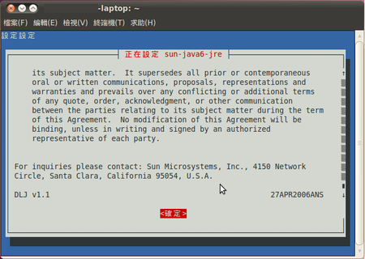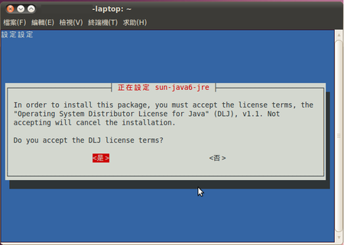

java version "1.6.0_26"  
Java(TM) SE Runtime Environment (build 1.6.0_26-b03)  
Java HotSpot(TM) 64-Bit Server VM (build 20.1-b02, mixed mode)

出現以上三行就表示安裝成功之後用firefox開啟http://www.pry.com/codeine/  
應該是還沒安裝如下圖，按install plugins

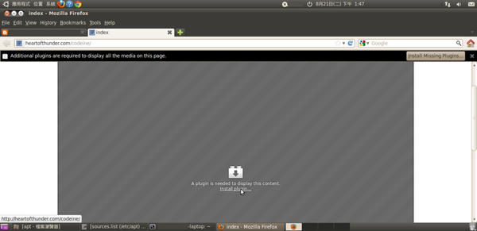

選Gnash SWF Player  
  
2.安裝Eclipse SDK(Software Development Kit)。

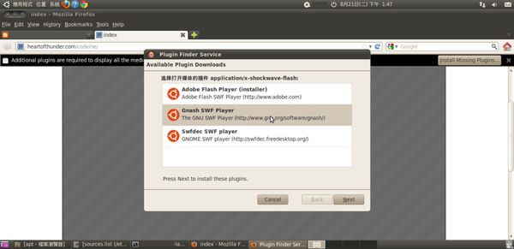

sudo apt-get install eclipse  
...

安裝完後 應用程式 -> 軟體開發 -> eclipse

Another way to install eclipse, go to <http://stackoverflow.com/questions/4767584/eclipse-3-6-helios-for-ubuntu-10-10> for more detailed information.

To install eclipse on ubuntu you need to download it first from <http://www.eclipse.org/downloads/> Extract the downloaded file by right click on it and extract here or running the following:

tar xzf dir/eclipse-SDK-3.3.1.1-linux-gtk.tar.gz

Where eclipse-SDK-3.3.1.1-linux-gtk is your eclipse-SDK name with version and dir is the directory of eclipse-sdk.

Now move it to the root directory. Apply the following command to do this.

sudo mv dir/eclipse ~

Now you are ready to configure your eclipse. To do this follow the following step by step...

sudo mv eclipse /opt/

Take care of the permissions:

sudo chmod -R +r /opt/eclipse

sudo chmod +x /opt/eclipse/eclipse

Create an executable in your path:

sudo touch /usr/bin/eclipse

sudo chmod 755 /usr/bin/eclipse

sudo gedit /usr/bin/eclipse

Copy the following content and save the file:

#!/bin/sh

export ECLIPSE_HOME="/opt/eclipse"

$ECLIPSE_HOME/eclipse $*

Let’s also make eclipse executable everywhere by creating a symlink:

sudo ln -s /usr/bin/eclipse /bin/eclipse

Create the menu icon:

sudo gedit /usr/share/applications/eclipse.desktop

Type in this content and save:

[Desktop Entry]

Encoding=UTF-8

Name=Eclipse

Comment=Eclipse IDE

Exec=eclipse

Icon=/opt/eclipse/icon.xpm

Terminal=false

Type=Application

Categories=GNOME;Application;Development;

StartupNotify=true

Run for the first time:

eclipse -clean

You can now start Eclipse by simply typing eclipse in the terminal or from the GNOME menu Applications -> Programming -> Eclipse  
開啟eclipse(注意這版本是GALILEO)那就接著第三步驟安裝CDT  
3.安裝CDT(C/C++ Development Tooling)。

開啟eclipse 按下上方工具列 Help -> Install New Software...  
按下Add

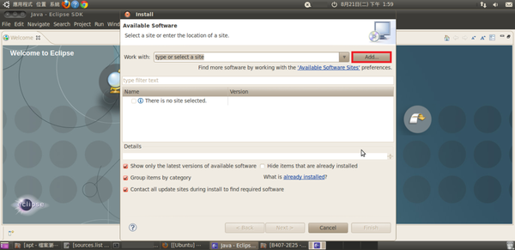

注意location的部分galileo 是根據你下載的eclipse版本  
http://download.eclipse.org/tools/cdt/releases/galileo

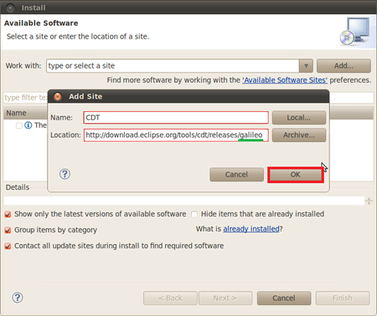

到這只選擇CDT Main Features另外一個下載會有問題反正那個可以不用沒關係所以就不選

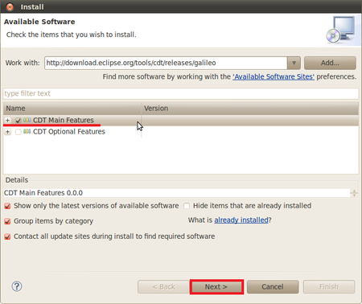

按下Next

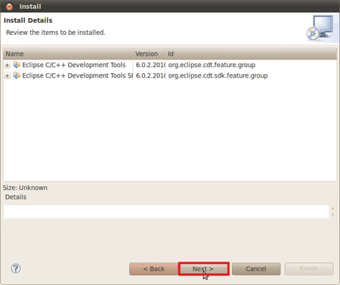

選accept，再按Finish

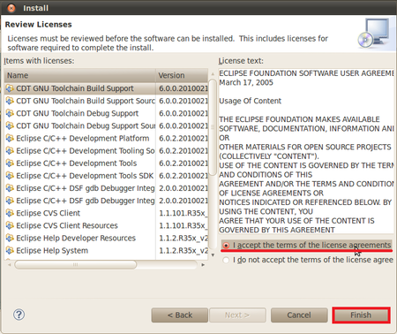

Select ALL，OK 即安裝完成CDT

